DEV_SETUP DOCUMENTATION ASSIGNMENT

INSTALLATION OF VISUAL STUDIO CODE TEXT EDITOR

* 1. Step 1: Download the .exe file from the internet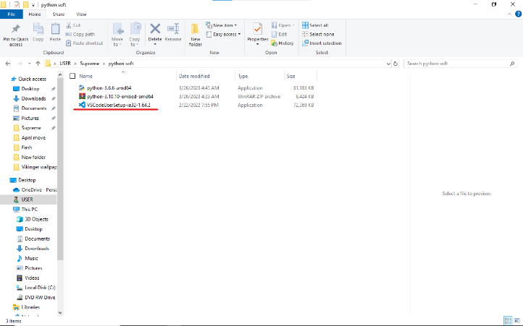
  2. Step 2: Run the .exe file on my laptop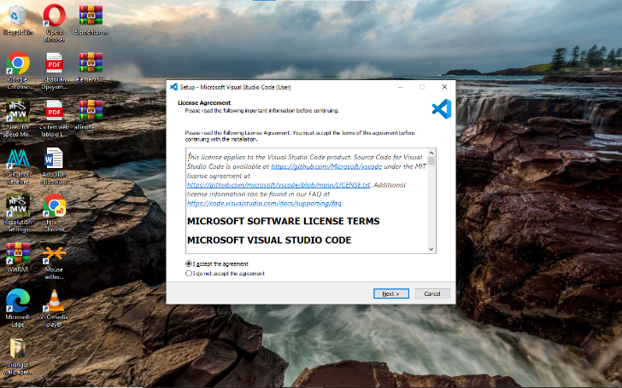
  3. Step 3: Accept the agreement and click the next button to the next page where you select the destination folder.

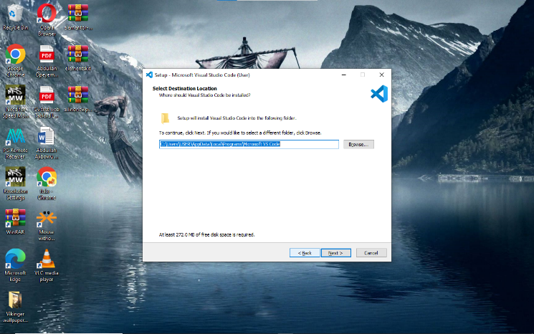

* 1. Tick the additional tasks and install. 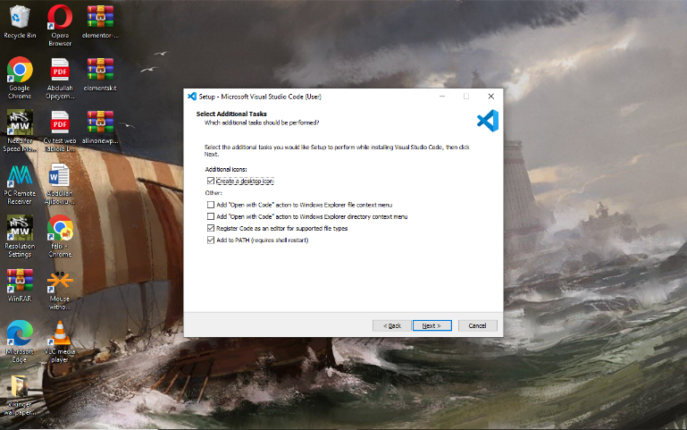
  2. The installation will start. 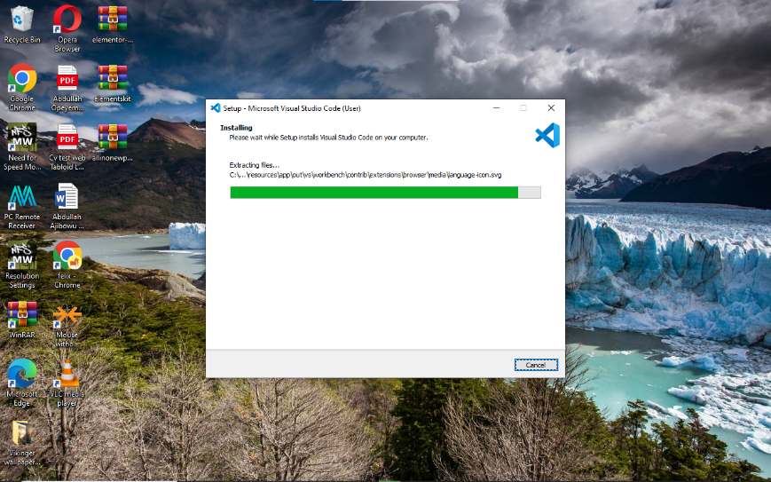
  3. Click the finish button to end the installation process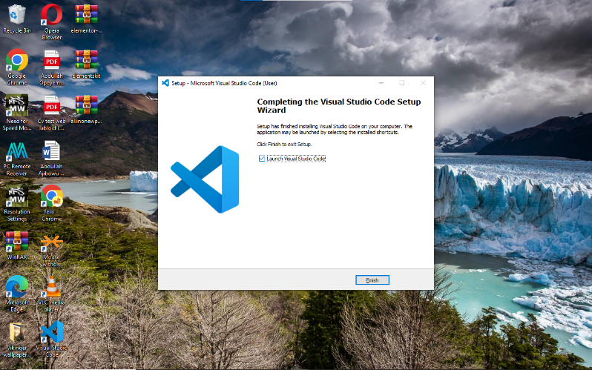.

INSTALLATION OF PYTHON

Step 1: Download the exe file 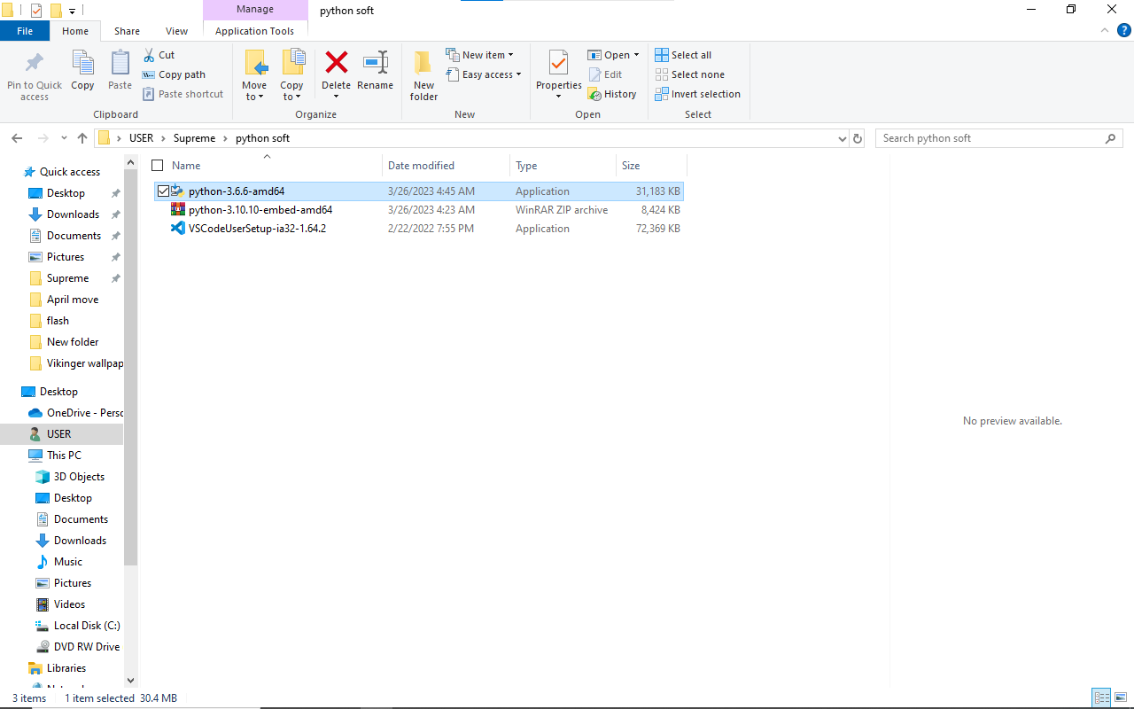

Step 2: Run the .exe file on my laptop

Step 3: Tick the Add Path and click install now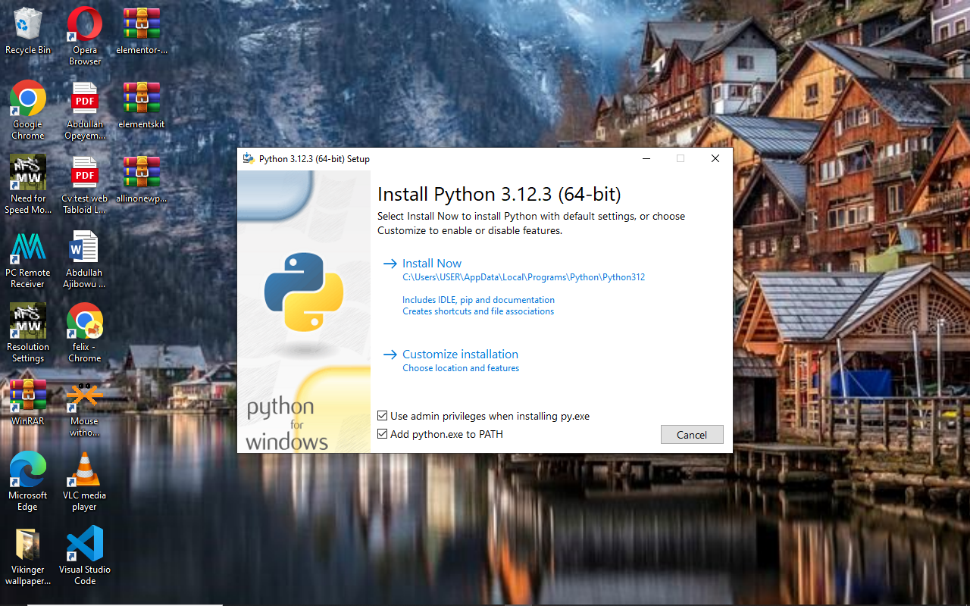

Step 4: The installation will start and click finish when completed. 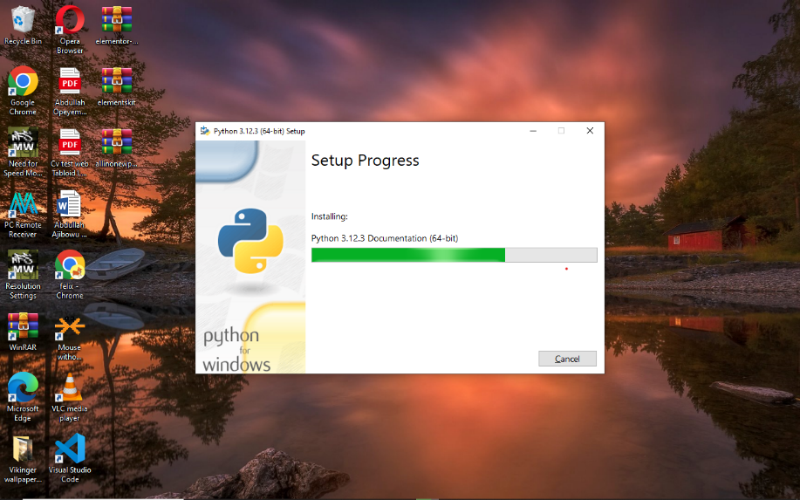

MYSQL INSTALLATION

Step 1: Right click and install the downloaded MySQL file

Step 2: Accept the user account control

Step 3: Click on custom setup type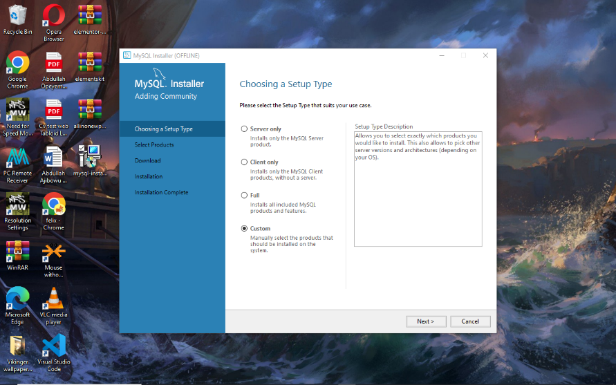

Step 4: Select the product to be installed (server, workbench and shell) and click next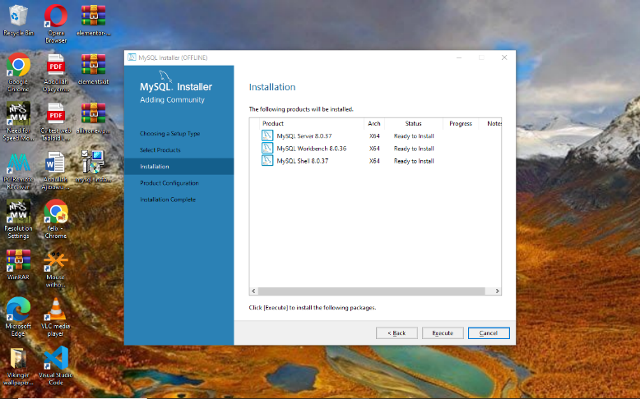

Step 5: Click on the execute button to download the selected product and install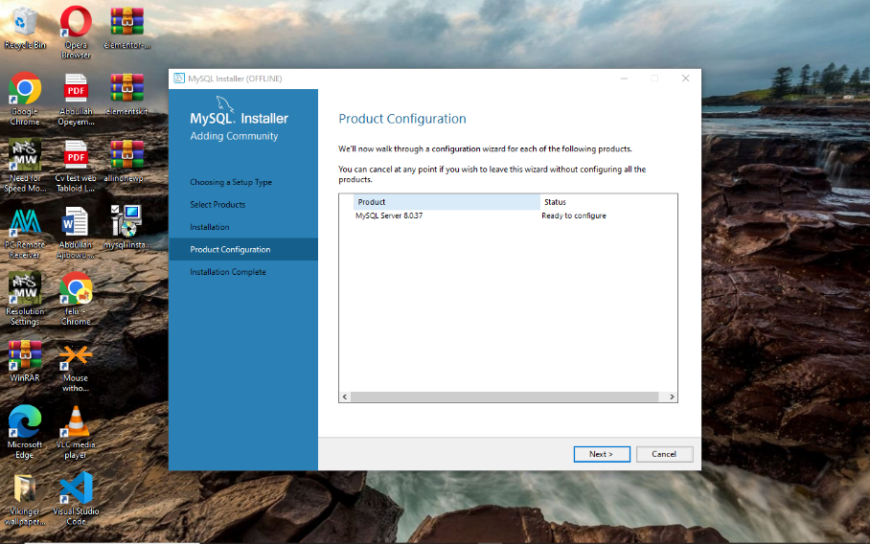

Step 6: Click next to configure the product

Step 7: Set the root password 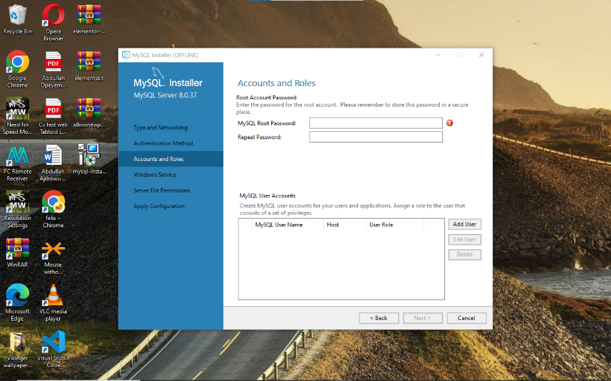

Step 8: Click next to set configurations

Step 9: Apply configurations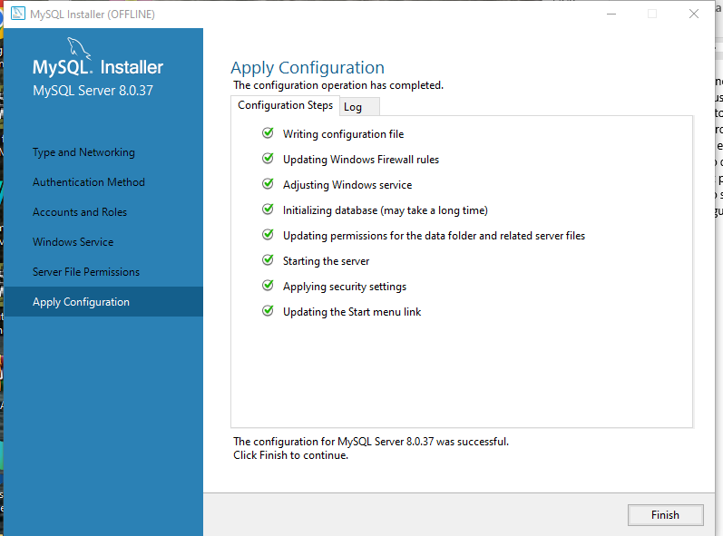

Step 10: Click the finish button

Now the workbench and shell is ready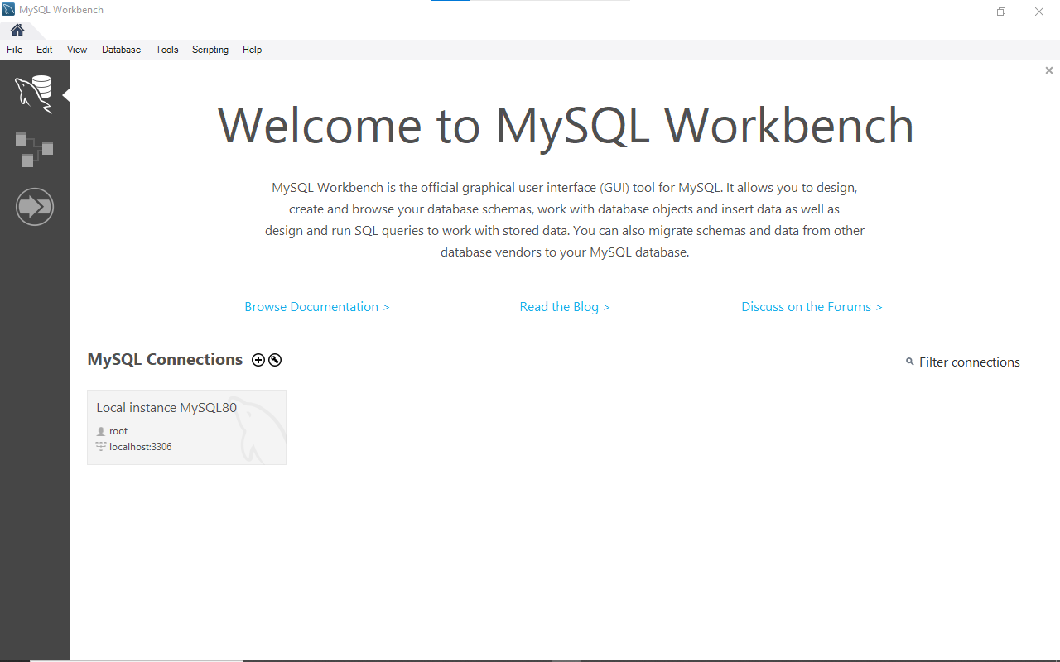

VERSION CONTROL INSTALLATION GIT

Step 1: Right click and install the setup file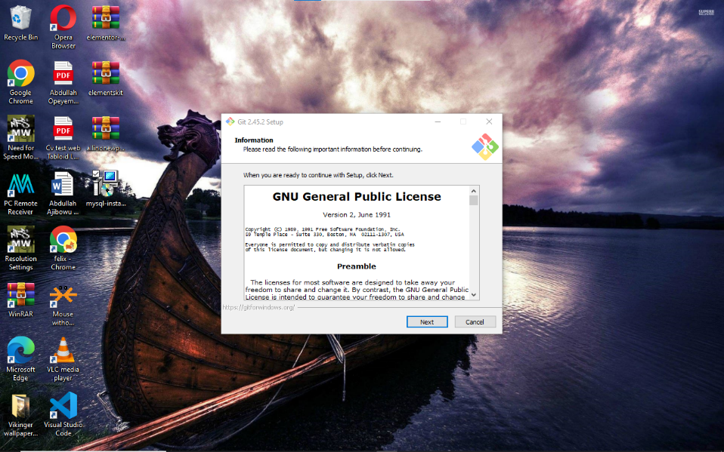

Step 2: Select the destination location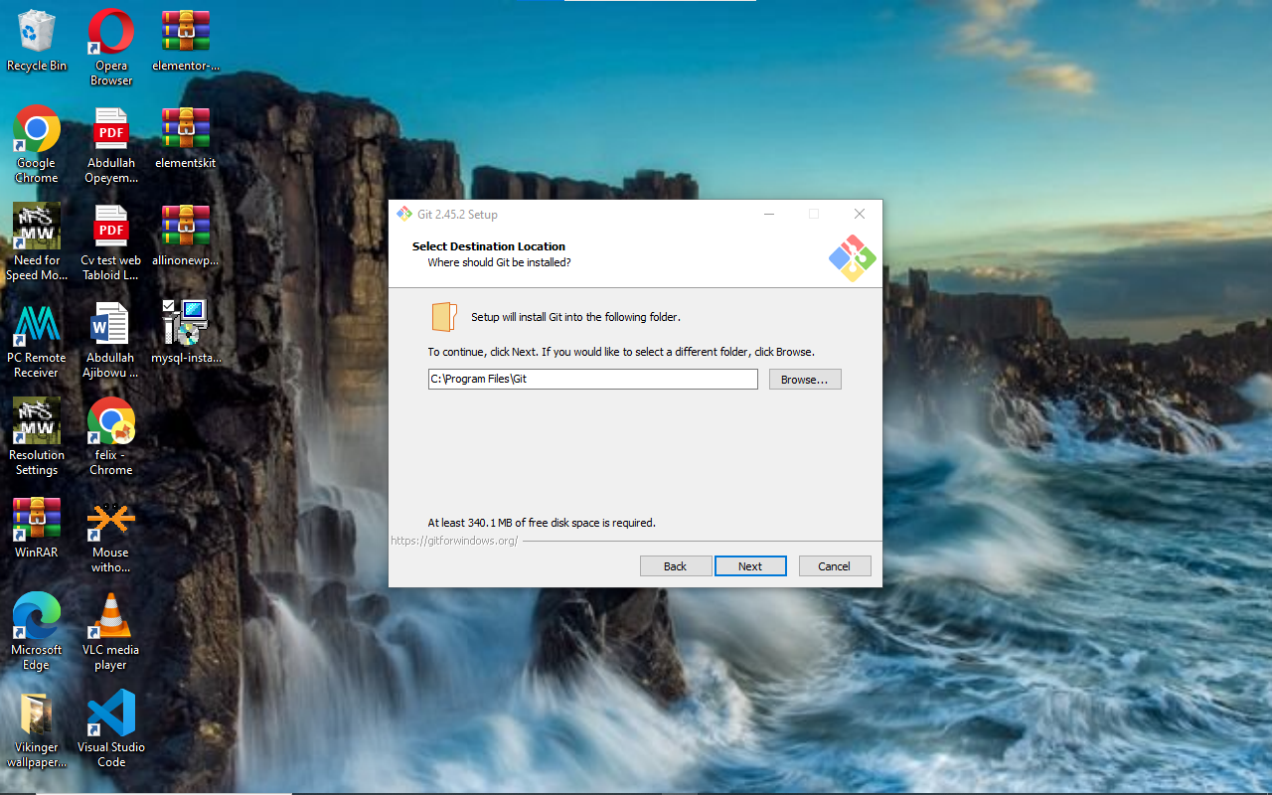

Step 3: Click next to Select component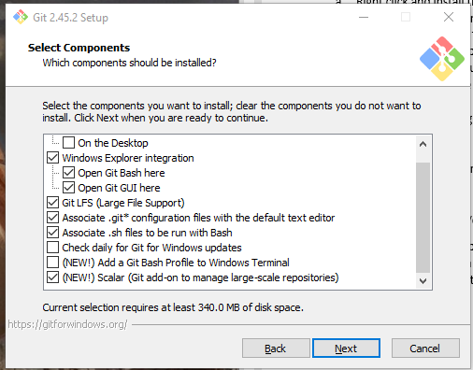

Step 4: Choose the default editor

Step 5: Click next to adjust configurations

Step 6: Choose a credential helper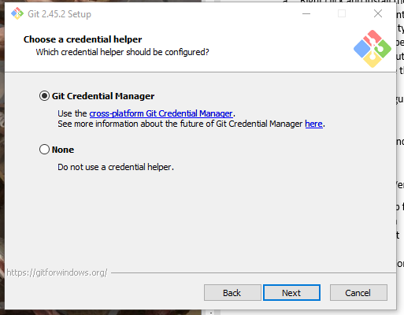

Step 7: Install start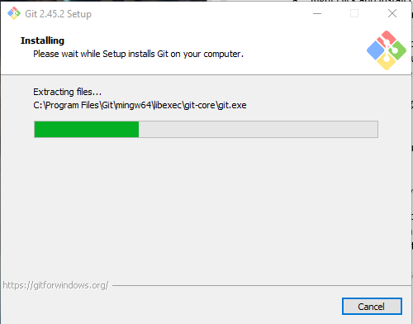

Step 8: Click finish after the installation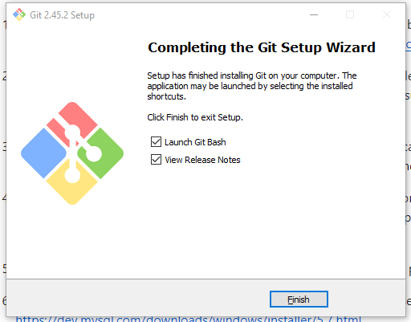

EXPLORING PYTHON EXTENSION

Step 1: Open Visual Studio Code Editor and click extension in the right pane

Step 2: Search python and install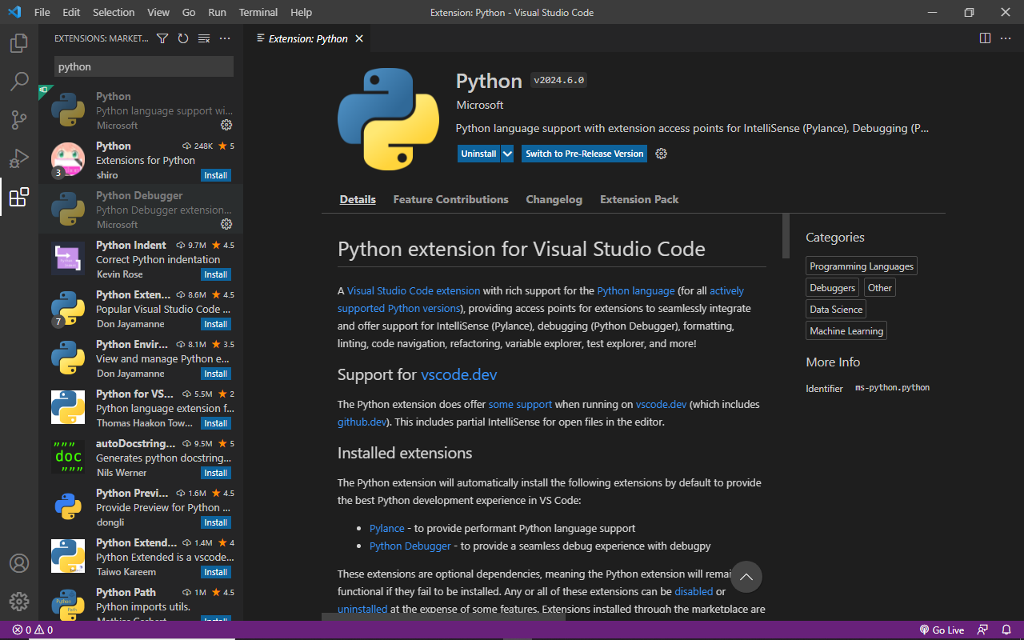

This are some of the software installed on my computer.

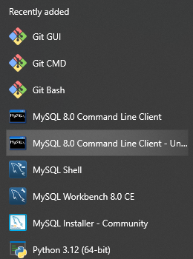

Conclusion: I faced little challenge in the process of installing the software because of the help of plp online classes, Youtube, blog, and the knowledge from previous software installation.